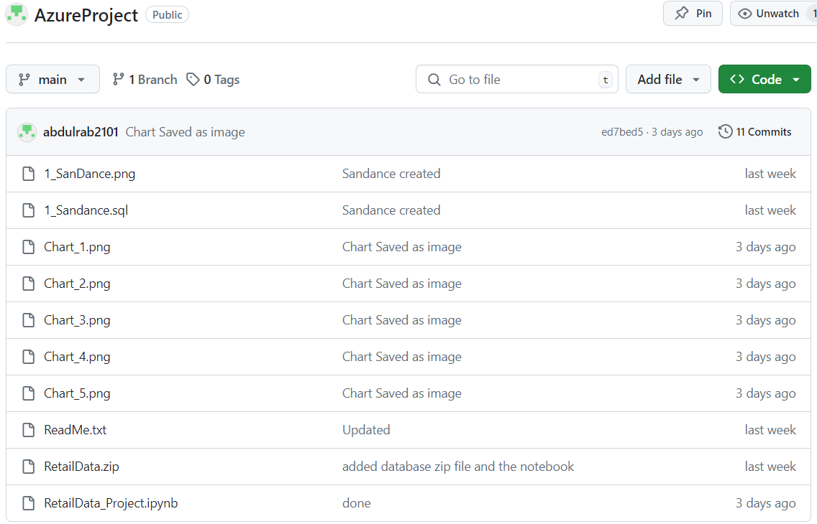

GitHub Link:

https://github.com/abdulrab2101/AzureProject.git